NAME______________________________

HW #5 Unit 2 - 10/22

MISTAKES CORRECTED No
INCLUDES REFLECTION No
REDO SHOWS WORK Neatly No
LATE    If you were absent, write “Absent” here:

DUE Wed. 10/24

___/4
Final Score:

INITIAL TEACHER FEEDBACK:
SHOW WORK PLEASE NEATER PLEASE
WRITE TIME SPENT PLEASE CORRECT

LEVEL 3 _____ ( √-, √, or √+)

25 Min. Time limit: This homework took

approximately ______ minutes.
OPTIONAL— Student feedback to teacher:

LEVEL ONE – Making Meaning
Improper
fraction:

Mixed
number:

#1. Solve by drawing

#2 Draw the fourth figure in this series:

Fig 1 Fig 2 Fig 3.

Can you fill in the blanks?
 | Figure 1 | Figure 2 | Figure 3 | Figure 4 | Figure 5 | LEVEL 2:  Figure # 10? | LEVEL 3:  Figure # 43?
Number of helmets | 3 | 10

LEVEL 2: Happy Numbers:

PROCEDURE:
- Square each DIGIT separately
- Add the results
- Repeat , Keep repeating
RULE:
- If you end up with a final sum of ONE, the number is happy

#3 . Is 32 happy or unhappy?
32:

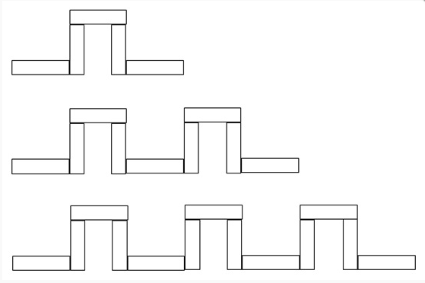
#4.

Figure 1

Figure 2

Figure 3:

Can you fill in the blanks?
 | Figure 1 | Figure 2 | Figure 3 | Figure 4 | Figure 5 | LEVEL 3:  Figure # 43?
Number of squares | 5 | 9

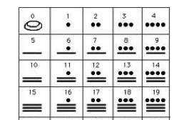
LEVEL 3: CHALLENGE

COUNTING LIKE A
MAYAN

Base – 20 system: 445 572
One 400, 2 twenties and 5 ones One 400, 8 twenties and 12 ones
= 400

= 160

=12

- - - - -

- - - - -

- - - - -

- - - - -

400’s Place

- - - - -

20’s Place

- - - - -

1’s Place
= 400

= 40

=5

CHALLENGE PROBLEMS
455 602 906

- - - - -

- - - - -

- - - - -

- - - - -

- - - - -

- - - - -

HOMEWORK CORRECTIONS:

NOTES TO SELF:

____________________________________________________________________________________________________________________________________________________________________________________________________________________

