CLASSWORK 9/4 NAME___________________
- LEVEL ONE:
THE The The

The BROKEN CALCULATOR….
How many of these numbers
can you still make?

4 = | 11 = | 23 = | 30 =
32 = | 33 = | 34 = | 35 =

2. LEVEL TWO: PARTYTIME!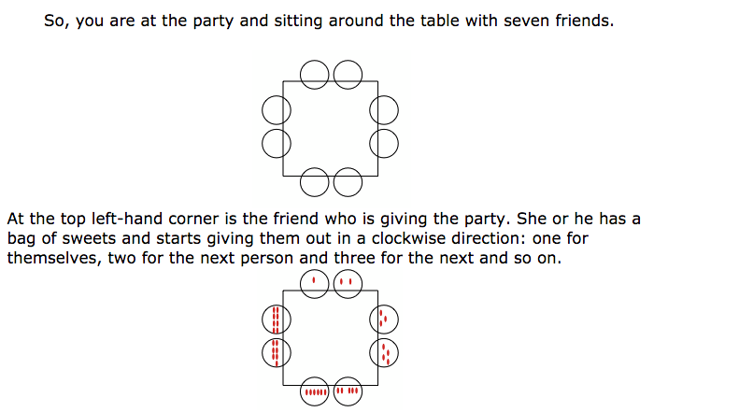

- How many sweets did the host pass out altogether?

- How many sweets (in total) do children sitting across from each other have? What are the possibilities?

- Are these “opposite totals” always even, or always odd? Why ? ?

2. What if there are THREE people on each side of the table? Draw this situation:
2

1
3‘’’
How many sweets did the host pass out altogether?

3. What if there are FOUR people on each side of the table? Draw this situation:
How many sweets did the host pass out altogether?

4. What if there are FIVE people on each side of the table? Draw this situation:
How many sweets did the host pass out altogether?

5. Can you fill out this table? (the last column is just for challenge! Can you find a pattern?)

Number of total guests | 4 | 8 | 12 | 16 | 20 | 24
Number of total sweets |  | 36 |  |  |  | ??

WHO LET THE DOGS OUT?

If B did it, then ...
 | 1 | 2
A
B
C
D

If A did it, then ...
 | 1 | 2
A
B
C
D

If C did it, then ...
 | 1 | 2
A
B
C
D

If D did it, then ...
 | 1 | 2
A
B
C
D

