DUE Wed. Oct. 2, due to holidays
30 minute time limit for this one HW.

NAME______________________________

HW #7 9/26, Unit 1 Tri 1

2nd FEEDBACK FROM TEACHER:
Please Correct Mistakes
Please Reflect on Your Work
Please Show Work on Redo
LATE    If you were absent, write “Absent” here:

FIRST FEEDBACK FROM TEACHER:
SHOW WORK PLEASE NEATER PLEASE
WRITE TIME SPENT PLEASE CORRECT

LEVEL 3 _____ ( √, √+, or √++)

FEEDBACK FROM STUDENT:
1. Time Limit: This homework took
$≤$30 Minutes MORE Than 30 Minutes, because ________________________________

2. How I feel about this HW:
LEVEL 1:    because _______
LEVEL 2: because _______
LEVEL 3: because _______

Use your fraction template if you like.
LEVEL ONE – Making Meaning
Solve visually:

- 1. Add 5/9 and 2/3 by drawing it below. What is the sum?
Mixed number (1 whole and how many 9ths? )

Improper fraction (just count the 9ths)

Mixed number (1 whole and how many 12ths? )

Improper fraction (just count the 12ths)

- Add 5/6 and 3/4 by shading below. What is the sum?

- Add 1/2 and 5/6 by shading below. What is the sum?
Mixed number (1 whole and how many 3rds? )

Improper fraction (just count the 6ths, then simplify to 3rds)

LEVEL TWO – Egyptian Fractions
Rules
- You can only use unit fractions (fractions that have a ONE in the numerator).
- All the denominators must be different.

If you find these problems difficult, just do your best. Draw, draw draw! Draw the fractions on a separate piece of paper, or use sugar cubes

- Make THIRTEEN TWELFTHS using Egyptian rules.
(start with ½ !) Here’s a 12-wide wall:
$$\frac{13}{12}=$$

- Make ELEVEN EIGHTEENTHS.
Here’s an 18-wide wall:
$$\frac{11}{18}=$$

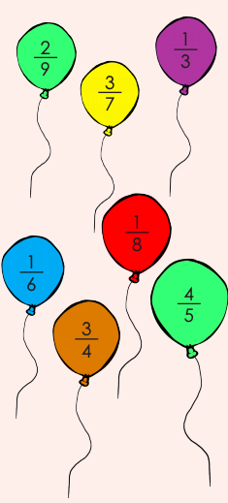
LEVEL THREE

- Pick any TWO fractions to add.
There might be more than one possible answer –
if so, look or the easiest pair to add! Write the sum as well.

- The sum should be greater than 1/3, but less than 1.

(sum >1/3 but < 1 )

- Sum should be less than ½ (< ½ )

- Sum should be greater than 1. ( >1)

- Grace chooses five different numbers from the list 1, 2, 3, 4, 5, 6, 7, 8, 9, 10.
Two of those numbers are 4 and 5, and they are the only two numbers she picks that differ by 1. What is the greatest possible sum of the five numbers?

(“Differ by one” means they are only one apart, like 4 and 5, or 8 and 9, or 90 and 91.)

- A man who had 12 horses and 3 children wrote his will to leave 1/2 of his horses to Pat, 1/3 to Chris and 1/12 to Sam. However, just after he died one of his horses died too.
The family lawyer showed up (on his horse) to help with the estate. How did the family divide the 11 remaining horses so as to fulfil the terms of the will (without cutting any horses in half!)

