NAME______________________________

HW #8 Nov.4, Unit 2, Tri 1

2nd FEEDBACK FROM TEACHER:
Please Correct Mistakes
Please Reflect on Your Work
Please Show Work on Redo
LATE    If you were absent, write “Absent” here:

DUE Wed., Nov.6

FIRST FEEDBACK FROM TEACHER:
SHOW WORK PLEASE NEATER PLEASE
WRITE TIME SPENT PLEASE CORRECT

LEVEL 3 _____ ( √, √+, or √++)

FEEDBACK FROM STUDENT:
1. Time Limit: This homework took
$≤$20 Minutes MORE Than 20 Minutes, because ________________________________

2. How I feel about this HW:
LEVEL 1: because _______
LEVEL 2: because _______
LEVEL 3: because _______

LEVEL ONE – Making Meaning
Improper
fraction:

Mixed
number:

#1. Solve by drawing $\left(1\frac{3}{8}x 2\right)-\left( \frac{3}{4} x 2\right)$

Draw $1\frac{3}{8}$ twice, then cross out TWO sets of $\frac{3}{4}$ . (cross out 3/4 once, and then do it again!)

Level Two
#2. FIND THE SUM, using any method.
Answer

1 + 2 + 3 + 4 + 5 + ….. + 77 + 78 + 79 + 80 = _______

#3. Alpha has $2\frac{1}{2}$ as much money as Beta. Gamma has one dollar LESS than twice as much money as Alpha. Altogether the 3 people have $84. How much does Alpha have?

Sentence: Alpha has…

Level 3
#4. Sofia is ¾ as old as her sister. Together their ages add up to 28 years. In how many years will Sofia be 4/5 as old as her sister?

Sentence:

#5. 3/10 of the bills in Zachary’s wallet are one-dollar bills. The number of ten-dollar bills is $\frac{2}{3}$ of the number of his one-dollar bills. The number of five-dollar bills is $\frac{3}{2}$ of the number of ten-dollar bills. If the remaining 4 bills are twenty-dollar bills,

- How many bills does Zachary have? _____
- How much money does Zachary have altogether? _____

More Level 3 – 2 pzl. Pts. ROMAN NUMERALS
Roman numerals are expressed by letters of the alphabet:
I=1
V=5
X=10
L=50
C=100
D=500
M=1000
There are 3 basic principles for reading and writing Roman numerals:
1. A letter repeats its value that many times (XXX = 30, CC = 200, etc.). A letter can only be repeated three times.
2. If one or more letters are placed after another letter of greater value, add that amount.

VI = 6 (5 + 1 = 6)

LXX = 70 (50 + 10 + 10 = 70)

MCC = 1200 (1000 + 100 + 100
= 1200)
3. If a letter is placed before another letter
of greater value, subtract that amount.

IV = 4 (5 – 1 = 4)

XC = 90 (100 – 10 = 90)

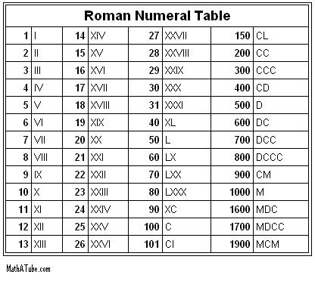
CM = 900 (1000 – 100 = 900)

Write the correct
number next to each
Roman numeral:
1)CDV=_______
2)DLX=_______
3)CML=_______
4)CXXV=_______
5)DLVI=_______
6)DLXXII=_______
7)CLXXIX=_______
8)DCCLXX=_______
9)CMXXXVII=_______ 10)DCLXXXIV=_____

