HW Guidelines:
The Parents’ Role: We discourage direct parent supervision of HW, since the HW then no longer provides feedback to students on their own mastery. Additionally, parents (meaning well!) will provide their child with a shortcut algorithm. This “short-wires” the learning process for the child. Yes, the algorithm is faster than the visual/ conceptual approach, BUT it does not transfer as well! It does not transfer to difficult word problems, or to rational expressions in algebra. If we only teach the four ‘shortcut’ algorithms for fractions, many students confuse the rules. (“Is this the one where I flip one fraction upside down and then add the tops only...? … Every middle school and high school teacher has heard questions like this!) The visual/conceptual approach takes longer, but it gives students something to fall back on. They’re better prepared for middle school and high school when they leave us with a solid conceptual understanding of fractions.

- Frequency. We give one homework assignment every other day, to provide flexibility around family schedules.

- Levels: The 3 levels of HW are “Concrete/Pictorial”, “Transfer to the Abstract” and “Challenge” . This reflects the Singaporean philosophy of how children learn math (Concrete -> Pictorial -> Abstract). It is explained in the file “Parent Page”, and visible on each HW assignment, quiz and class work sheet.

- Time Limit: Each HW assignment has a total of a 25-minute time limit. We believe most of students’ learning should be done in the classroom. Homework should provide a little extra thinking and reflecting time. It should provide feedback TO THE STUDENT on how they’re progressing when they work independently, and what they need to keep working on. After spending (a focused) 25 minutes on HW, students can stop, without penalty for not finishing. We soon know our students’ working speed (from classwork) and can tell when they’ve spent substantially less or more than 25 min. on homework. In this case, we have a talk with the child, and if needed, with the parents. It helps if we keep homework short, avoid repetition, and encourage thinking, which can be fun. (see Parent Sheet for more info)

- Grading
- Showing Work: If homework is sloppy, we mark the box “Neater Please” at the top of the page. Over time, we expect improvement in showing work. This is communicated to the student and their parents at midterm and at the end of the trimester, and should become a highlight of their goal setting in advisory.

- Time Spent; If it seems the child has put in good effort at the appropriate levels, but not finished in the time limit, there is no consequence.

- Correcting We feel it is important to return HW the day after it was handed in. We only mark problems with a check √ for correct, or an x for incorrect. It is important that the students investigate their own mistakes. We hand out a “HW Correction Sheet” for students to use when correcting. (see page 3 below) Teaching the correction process takes MONTHS, but is very important. It is part of student ownership of their own learning.
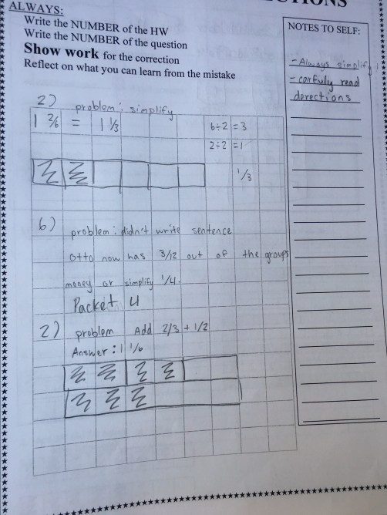
An example of a student’s corrections:
Important messages we want to reinforce with students:
- We do not penalize for mistakes, as long as they are corrected. There IS a penalty for not correcting.
- Corrections must show work, to explain how the problem is done correctly.
- Corrections must include a “Note to Self” on what they can do to avoid that mistake in the future. (“Draw a model”, “Always simplify”, “Just count the shaded boxes”…)
Reflecting on their mistakes is very difficult at this age. Students tend to focus on getting down the “right answer” rather than finding the source of their own mistake. Their reflection might read “Don’t make careless mistakes”, which says nothing about the actual source of the mistake.
We share our own correction examples. We call on brave students to share their correction examples (this is always a marble in the extra recess jar!) This is a long process, but an important one.

