∑œ

**HW #7** NAME_________________________

DUE ___ _____

FEEDBACK FROM TEACHER:

SHOW WORK PLEASE NEATER PLEASE WRITE TIME SPENT PLEASE CORRECT

LEVEL 3  *_____* *( √, √+, or √++)*

TIME SPENT: ___________________

Student feedback: (optional) _____________________________________________

Use the fraction template if you like:

**LEVEL ONE – Making Meaning**

Sum = $\frac{8}{10} or \frac{4}{5}$

1. Add 3/10 and 1/2 using the grid

below. (draw 10ths)

|  |  |  |  |  |  |  |  |  |  |  |  |
| --- | --- | --- | --- | --- | --- | --- | --- | --- | --- | --- | --- |
|  |  |  |  |  |  |  |  |  |  |  |  |
|  |  |  |  |  |  |  |  |  |  |  |  |
| *Notes:*   * *Don’t require simplifying until that visual process makes sense (in the coming weeks)* * *The dots on the shaded parts show that the student was* ***counting*** *up the total sum, which is great.* * *Drawing 2 bars is fine, too.* * *Don’t be inflexible about how the drawing is made, as long as it makes sense.* | | | | | | | | | | | |

Sum = $\frac{7}{6} or 1\frac{1}{6}$

1. Add 2/3 and 1/2 by using the grid

below. (draw 6ths)

|  |  |  |  |  |  |  |  |  |  |  |  |
| --- | --- | --- | --- | --- | --- | --- | --- | --- | --- | --- | --- |
|  |  |  |  |  |  |  |  |  |  |  |  |
|  |  |  |  |  |  |  |  |  |  |  |  |
|  |  |  |  |  |  |  |  |  |  |  |  |

Sum = $\frac{17}{8} or 2\frac{1}{8}$

1. Add 3/4 and 7/8 and 1/2 by using the grid below.

(draw 8ths)

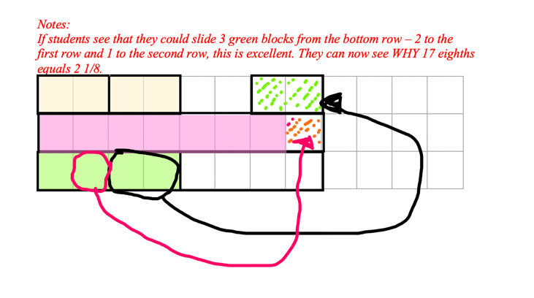

|  |  |  |  |  |  |  |  |  |  |  |  |
| --- | --- | --- | --- | --- | --- | --- | --- | --- | --- | --- | --- |
|  |  |  |  |  |  |  |  |  |  |  |  |
|  |  |  |  |  |  |  |  |  |  |  |  |
|  |  |  |  |  |  |  |  |  |  |  |  |



**LEVEL TWO – Transferring Understanding**

4. Word Problem - Rohan spent  of his money on a bike and  of his REMAINING money on a helmet. If the helmet cost $30, how much did the bike cost? *Note: Since there are 3 units REMAINING,*

*1/3 of those units equals ONE unit for the helmet.*

|  |  |  |  |  |  |  |  |  |  |  |  |  |  |  |  |
| --- | --- | --- | --- | --- | --- | --- | --- | --- | --- | --- | --- | --- | --- | --- | --- |
|  |  |  |  |  |  |  |  |  |  |  |  |  |  |  |  |
|  |  |  |  |  |  |  |  |  |  |  |  |  |  |  |  |
|  |  |  |  |  |  |  |  |  |  |  |  |  |  |  |  |

***$30 per unit***

***30 x 7 = 210***

***The bike cost $210***

*helmet*

*b i k e*

*b i k e*

*b i k e*

*b i k e*



*remaining money*

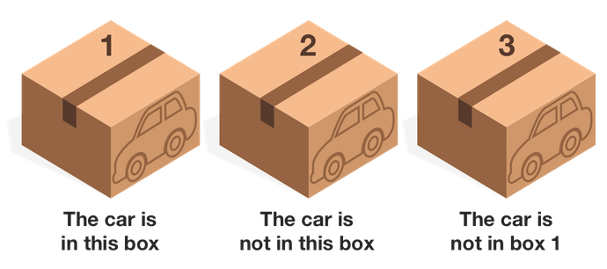**LEVEL THREE – Challenge** *- show your thinking in a truth table or words.*

There are three boxes.

Exactly one of them contains a car.

On each box there is a statement,

but only ONE of them is true.

The other 2 are false.

Which box contains the car? ____***Box 2***____

5.

|  |  |  |
| --- | --- | --- |
| ***T*** | *F* | *F* |
| *F* | ***T*** | *F* |
| *F* | *F* | ***T*** |

*The 3 possibilities are that #1 is true, or #2*

*is true, or #3 is true.*

*In each case, the other two must be false.*

*Read through each statement – we see*

*that the 2nd statement in the first row doesn’t work, and in the 2nd row, the first and third statements contradict. So… the third row is correct. Box 2 (“not in this box”) is false, therefore it IS in box 2. The first statement in that row is false, and the last statement is true, so it works.*

6. Alpha’s salary is  of Beta’s salary. Beta’s salary is  of Gamma’s salary. Express Alpha’s salary as a fraction of Gamma’s salary. (no equations needed) *Hint: draw 16 units for Gamma, then mark them into 8ths.)*

|  |  |  |  |  |  |  |  |  |  |  |  |  |  |  |  |  |
| --- | --- | --- | --- | --- | --- | --- | --- | --- | --- | --- | --- | --- | --- | --- | --- | --- |
|  |  |  |  |  |  |  |  |  |  |  |  |  |  |  |  |  |
| A |  |  |  |  |  |  |  |  |  |  |  |  |  |  |  |  |
| B |  |  |  |  |  |  |  |  |  |  |  |  |  |  |  |  |
| G |  |  |  |  |  |  |  |  |  |  |  |  |  |  |  |  |
|  |  |  |  |  |  |  |  |  |  |  |  |  |  |  |  |  |
| *Alpha’s salary is 5/16 of Gamma’s salary.* | | | | | | | | | | | |  |  |  |  |  |