Number Bonds: Draw in the missing dots.
1.
Pictorial
NAME______________________

Circle the box that is GREATER: 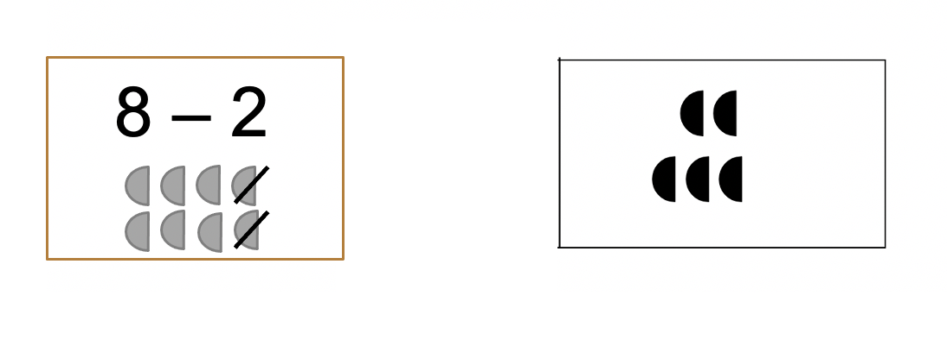
2.

3. Number Bonds: Fill in the missing boxes.


Challenge:

24
1.
Share 24
equally
between the
four
boxes.
Feel free to use
blocks.

2.
Andrew decorated 20 cookies to take to a party.
He lined them up and put icing on every second cookie.
Then he put a cherry on every third cookie.
Then he put a chocolate button on every fourth cookie.
So there was nothing on the first cookie.
How many other cookies had no decoration? Did any cookies get all three decorations?


