Puzzle Packet #5

NAME__________

Points ____(Teacher fills out)

Due Date : __________

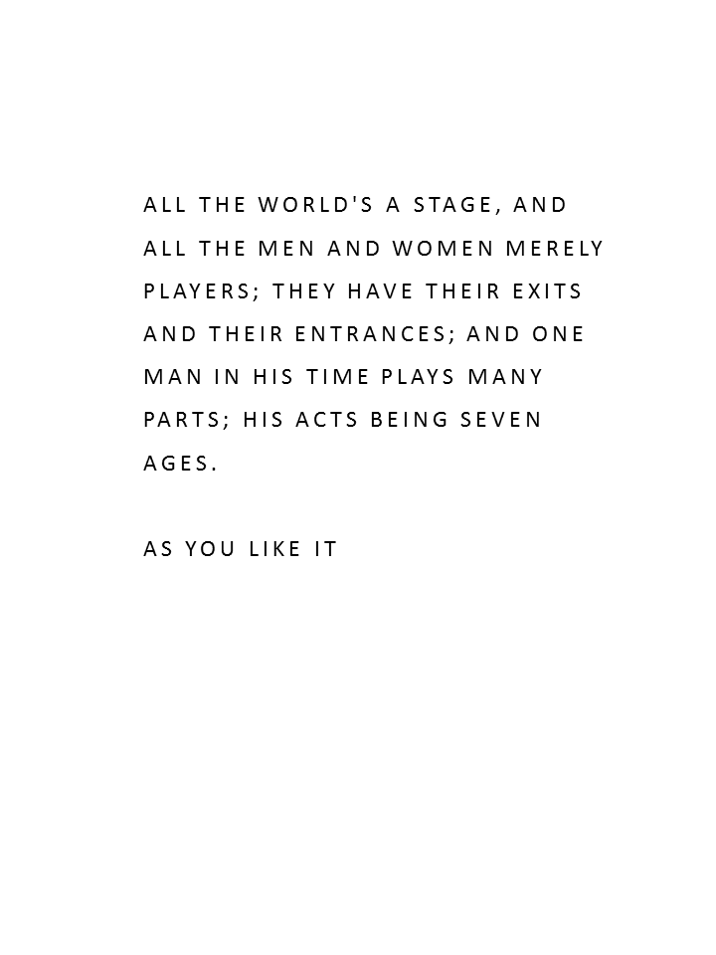

Cryptogram

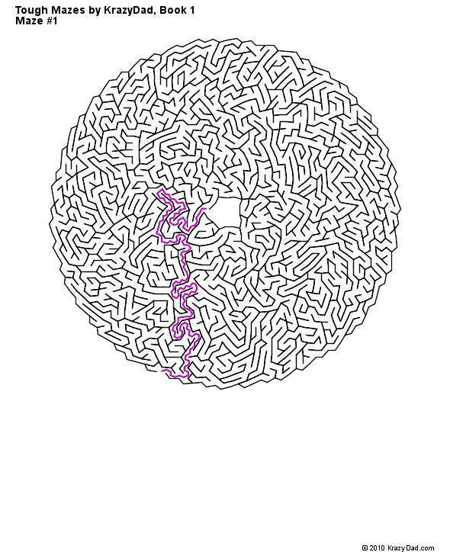

MARUPEKE PUZZLES -
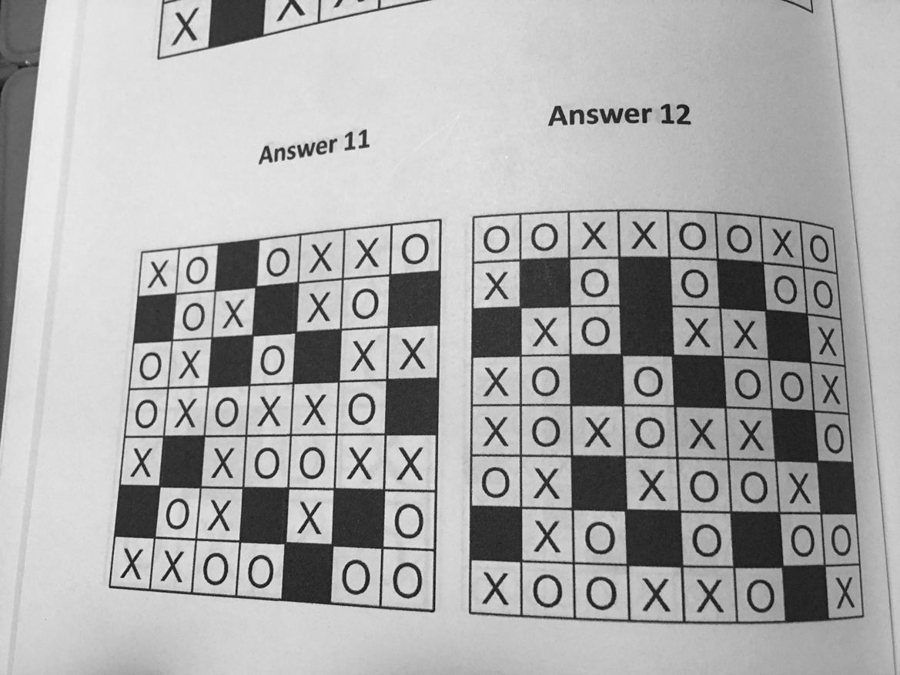

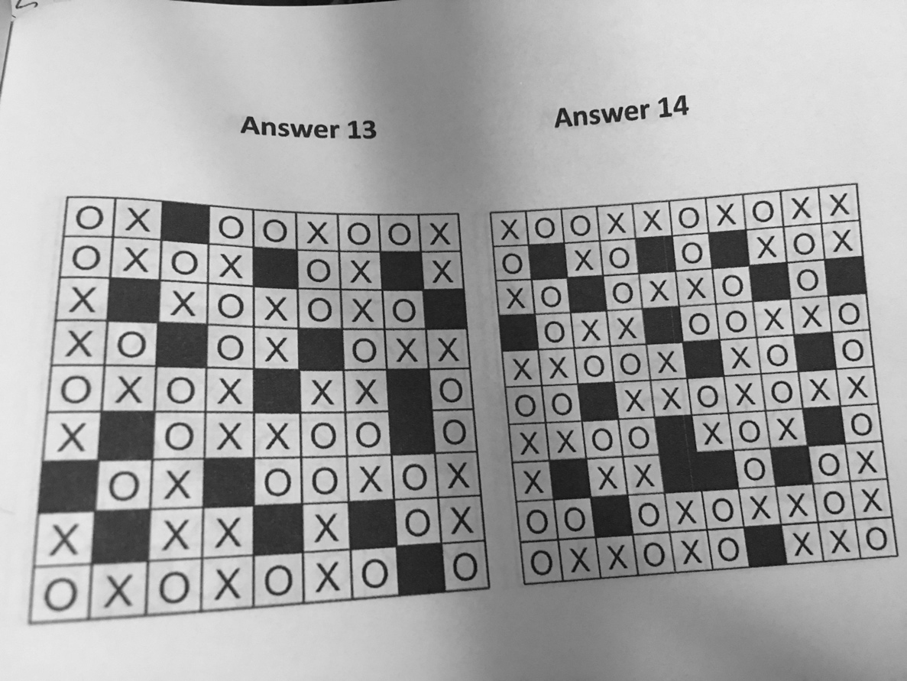

Battleships --
1 ½ points each

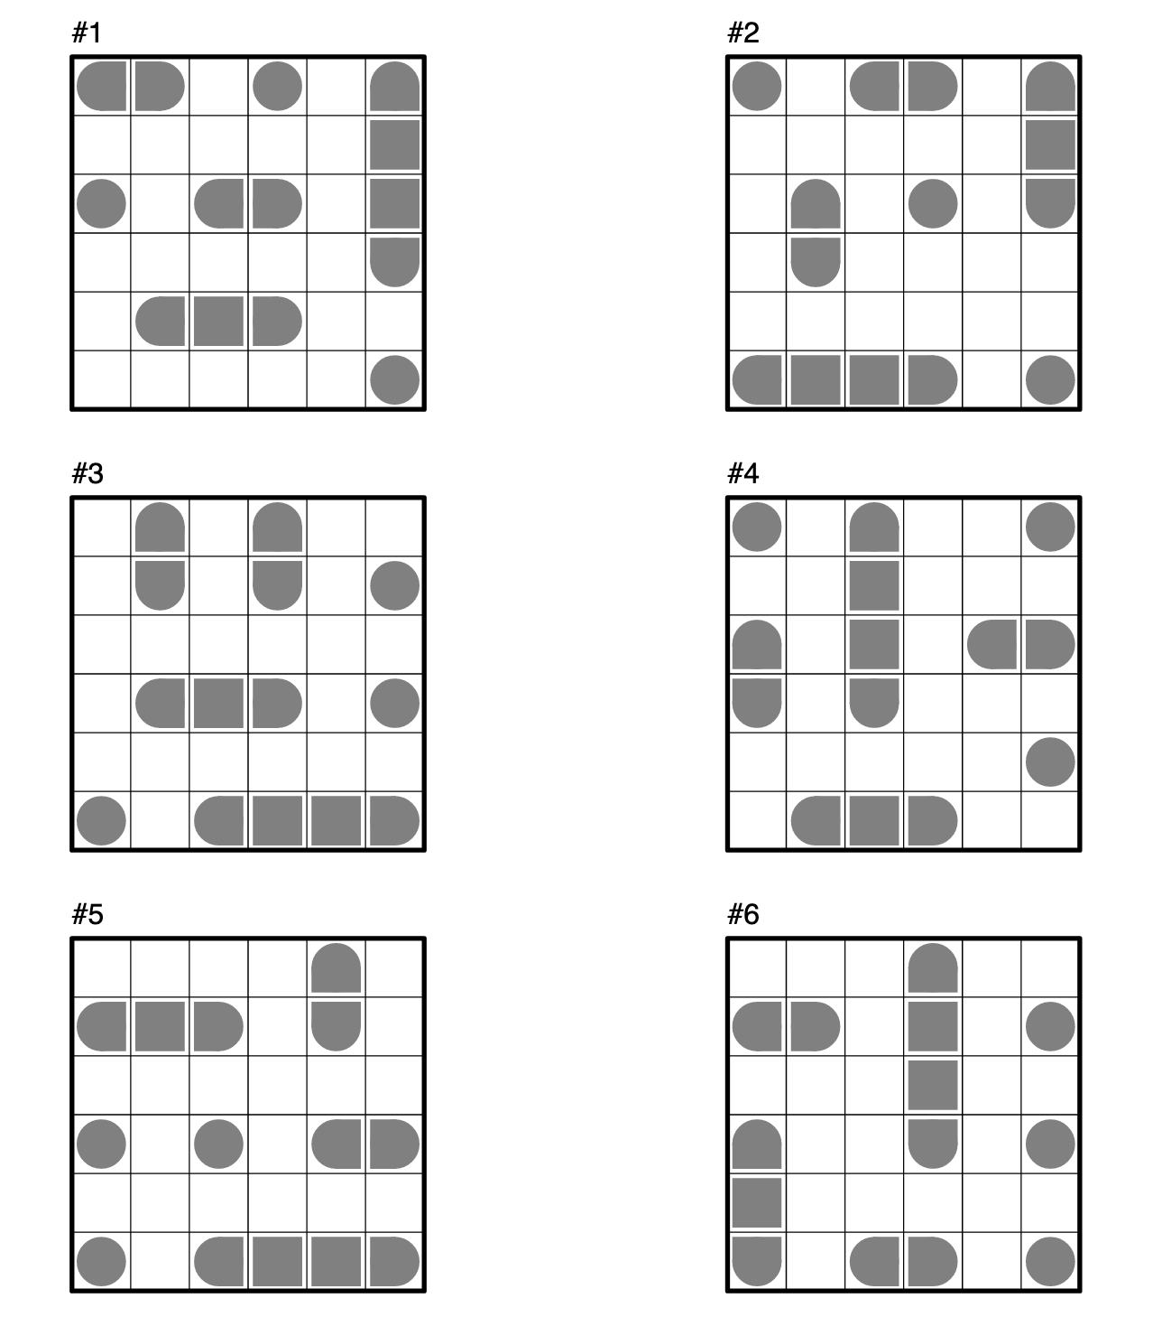

LOGIC PUZZLES

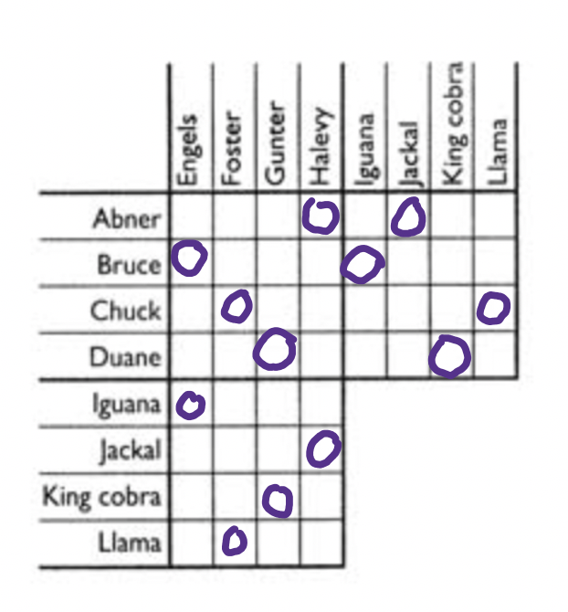
PETS!
Each of four men owns a different species of exotic pet. From the following clues, can you figure out each man’s full name and what kind of pet he owns?
- Mr. Engels (whose pet is named Sparky), Abner, and Mr. Foster all belong to a club for owners of unusual pets.
- The iguana isn’t owned by either Chuck or Duane.
- Neither the jackal nor the king cobra is owned by Mr. Foster.
- The llama doesn’t belong to Duane (whose pet is named Waggles).
- Abner, who doesn’t own the king cobra, isn’t Mr. Gunter.
- Bruce and Mr. Foster are neighbors.
- Mr. Halevy is afraid of iguanas.
COWS!!
