1. Color the first 5 triangular numbers here:

**5th**

triangular #

|  |  |  |  |  |  |  |  |  |  |  |  |  |  |  |  |  |  |  |  |  |
| --- | --- | --- | --- | --- | --- | --- | --- | --- | --- | --- | --- | --- | --- | --- | --- | --- | --- | --- | --- | --- |
|  |  |  |  |  |  |  |  |  |  |  |  |  |  |  |  |  |  |  |  |  |
|  |  |  |  |  |  |  |  |  |  |  |  |  |  |  |  |  |  |  |  |  |
|  |  |  |  |  |  |  |  |  |  |  |  |  |  |  |  |  |  |  |  |  |
|  |  |  |  |  |  |  |  |  |  |  |  |  |  |  |  |  |  |  |  |  |
|  |  |  |  |  |  |  |  |  |  |  |  |  |  |  |  |  |  |  |  |  |
|  |  |  |  |  |  |  |  |  |  |  |  |  |  |  |  |  |  |  |  |  |
| *# of blocks:* | *1* |  |  | *3* |  |  | *6* |  |  | *10* | | | |  | *15* | | | | |  |
|  |  |  |  |  |  |  |  |  |  |  |  |  |  |  |  |  |  |  |  |  |
|  |  |  |  |  |  |  |  |  |  |  |  |  |  |  |  |  |  |  |  |  |

**4th**

triangular #

**3rd**

triangular #

**2nd**

triangular #

**1st**

triangular #

2. When we combine 2 consecutive triangular numbers, we can build a square!



a) What square can you build with the 2nd and 3rd triangular numbers ? (they have 3 and 6 blocks respectively). Draw the square below.

b) What square can you build with t the 3rd and 4th triangular numbers ? (they have 6 and 10 blocks). Draw the square below.

1. 3 & 6 b) 6 & 10

|  |  |  |  |  |  |  |  |  |  |  |  |  |  |  |  |  |  |  |
| --- | --- | --- | --- | --- | --- | --- | --- | --- | --- | --- | --- | --- | --- | --- | --- | --- | --- | --- |
|  |  |  |  |  |  |  |  |  |  |  |  |  |  |  |  |  |  |  |
|  |  |  |  |  |  |  |  |  |  |  |  |  |  |  |  |  |  |  |
|  |  |  |  |  |  |  |  |  |  |  |  |  |  |  |  |  |  |  |
|  |  |  |  |  |  |  |  |  |  |  |  |  |  |  |  |  |  |  |
|  |  |  |  |  |  |  |  |  |  |  |  |  |  |  |  |  |  |  |

c) Can you put it in words?

* The 2nd and 3rd triangular numbers combine to build a square of size _____
* The 3rd and 4th triangular numbers _________________
* The 4th and 5thtriangular numbers ____________________.

7. Challenge :

a) Can you find the 10th triangular number? (how many blocks in the 10th triangular #?) (Draw it or use any other method)

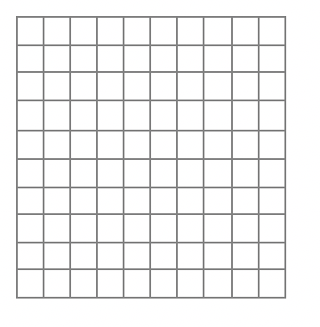

__________

b) What is the sum of the 10th and 11th triangular numbers ? ___________