HW #6 NAME_______________________

DUE ________

∑œ

FEEDBACK FROM TEACHER:
SHOW WORK PLEASE NEATER PLEASE WRITE TIME SPENT PLEASE CORRECT
LEVEL 3 _____ ( √, √+, or √++)

TIME SPENT: ___________________

Student feedback: (optional) ____________________________________________

LEVEL ONE
Answer:

#1. Solve by drawing: $2\frac{2}{3}-\left( \frac{2}{3} x 2\right)$

Draw $2\frac{2}{3}$ , then cross out TWO sets of $\frac{2}{3}$ . (cross out 2/3 once, and then do it again!)

 |  | X | X
 | X | X

Level Two
#2. FIND THE SUM, using any method.
Answer

2 + 4 + 6 + 8 + 10 + ….. + 92 + 94 + 96 + 98 + 100 = _______

#3. Natalie has ¾ as much money as Annabelle. Allen has one dollar LESS than twice as much money as Natalie. Altogether the 3 people have $129. How much does Allen have?

N |  |  |  |  |  |  |  |  |  |  |  | 129 + 1 = 130 for 13 units  130 ÷ 13 = 10 per unit  60-1 = 59
An
Al
Sentence: Allen has…
Level 3
#4. Susan is 39 years old. She is 3 times as old as her son. Find her age when, in the future, her son will be half as old as she.

SU |  |  |  |  |  |  |  |  | When the son has 2 units, Susan will have 4 units, and the son will be ½ her age.  Adding a unit adds 13 years.
SON
Sentence:

#5. A tank containing some cubes was 4/5 filled with water. When all the cubes were removed, the water level was only ¼ of its original height. There were 3 liters of water left in the tank at that point.
- What is the total capacity of the tank, in liters ? _____________
- If the volume of each cube was ½ of a liter,

how many cubes were there? ____________

 |  |  |  |  |  |  |  |  |  | b) It would take SIX ½ liter cubes to equal 3 liters. (3 liters = one unit box) So 18 cubes to fill 3 unit boxes.
 |  | W | W | W | W
More Level 3 2 pzl. Pts!! ROMAN NUMERALS

There are 3 basic principles for reading and writing Roman numerals:
I =1
V =5
X =10
L =50
C =100
D =500
M =1000

- A letter can repeat its value that many times (XXX = 30, CC = 200, etc.). A letter can only be repeated a maximum of three times.

2. If one or more letters are placed AFTER another letter of greater value, add that amount.

VI = 6 (5 + 1 = 6)

LXX = 70 (50 + 10 + 10 = 70)

MCC = 1200 (1000 + 100 + 100 = 1200)

3. If a letter is placed BEFORE another letter of greater value, subtract that amount.

IV = 4 (5 – 1 = 4)

XC = 90 (100 – 10 = 90)

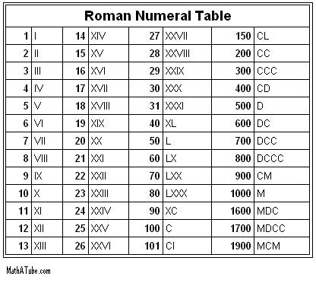
CM = 900 (1000 – 100 = 900)

Write the correct
modern number next
to each Roman numeral:

1) XLIV =_______

2) XCII=_______

3) LXXIV=_______

4) CCLIX=_______

5) MCMLXIX=_______

6) MMIV=_______

