HW #18 NAME_______________________

DUE ________

FEEDBACK FROM TEACHER:
SHOW WORK PLEASE NEATER PLEASE WRITE TIME SPENT PLEASE CORRECT
LEVEL 3 _____ ( √, √+, or √++)

TIME SPENT: ___________________

Student feedback: (optional) ____________________________________________

LEVEL 1:

- Label all the fractional markings on this “foot ruler”-

- Label all the fractional markings on this “foot ruler”-

LEVEL 2:
USE THE ANSWERS IN THIS ANSWER BANK FOR THE NEXT 3 PROBLEMS:
$$\frac{5}{8}+ \frac{1}{4}= \frac{7}{8}$$
$$\frac{3}{8}+ \frac{1}{8}= \frac{1}{2}$$
$$\frac{5}{8}+ \frac{1}{8}= \frac{3}{4}$$

- What is this SUM?

Example:

4. What is this SUM?
$$\frac{3}{8}+ \frac{1}{8}= \frac{1}{2}$$

5. What is this SUM?
$$\frac{5}{8}+ \frac{1}{4}= \frac{7}{8}$$

7. What is this DIFFERENCE?

This is being SUBTRACTED

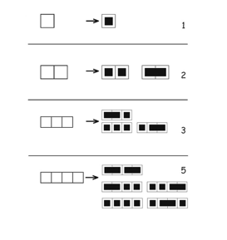
Examples:

Level 3 -

“Building with Ones and Twos”

Can you figure out the pattern just from studying the 4 examples?

8. Draw in the solution for these problems: POSSIBLE STRAGEGY:
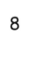

?

2 2 2
2 2 1 1
2 1 1 1 1
1 1 1 1 1 1

1 2 2 1
1 2 1 1 1

1 1 2 1 1
1 1 2 2
1 2 1 2
2 1 1 2
2 1 2 1
1 1 1 1 2
1 1 1 2 1

