Set 1
1a. 4.2 x 100 = ________
 | Thousands | Hundreds | Tens | Ones  1 | Tenths  1  1 | Hundredths  1  1
Before: |  |  |  | . | .
x 100

1b. 4.2 ÷ 10 = ________
 | Thousands | Hundreds | Tens | Ones  .  1 | Tenths  1  1 | Hundredths  1  1
Before: |  |  |  |  | .
÷ 10

1c. 20.01 x 100 = ________
 | Thousands | Hundreds | Tens | Ones  1 | Tenths  .  1  1 | Hundredths  1  1
Before:
x 100

.

1d. 640 ÷ 200 = ________

 | Thousands | Hundreds | Tens | Ones  1 | Tenths  1  1 | Hundredths  1  1
Before: |  |  |  |  | .  .
÷ 2
÷ 100 |  |  |  |  | .

1e. 6.4 x 200 = ________

 | Thousands | Hundreds | Tens | Ones  1 | Tenths  1  1 | Hundredths  1  1
Before: |  |  |  |  | .  .
X 2
x 100 |  |  |  |  | .

Set 2
2a.

What is this SUM?
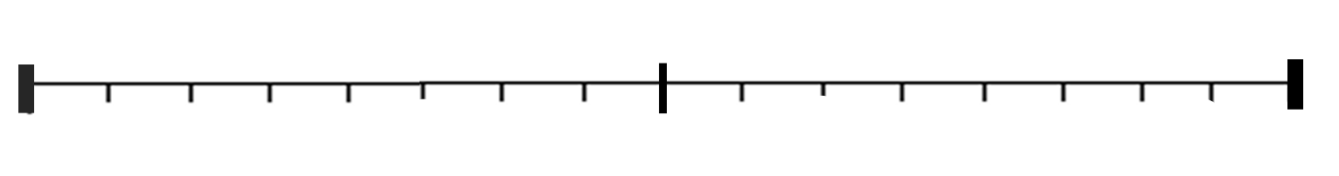
1

What is this DIFFERENCE?
1

This is being SUBTRACTED

2b.

630 ÷ 300 = ________

 | Thousands | Hundreds | Tens | Ones  1 | Tenths  1  1 | Hundredths  1  1
Before: |  |  |  |  | .  .
÷ 3
÷ 100 |  |  |  |  | .

2c. 2.4 x 300 = ________

 | Thousands | Hundreds | Tens | Ones  1 | Tenths  1  1 | Hundredths  1  1
Before: |  |  |  |  | .  .
X 3
x 100 |  |  |  |  | .

Set 3
3a.

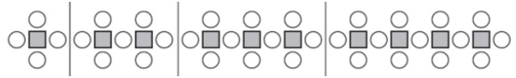
Figure 1 Figure 2 Figure 3 Figure 4

Can you fill in the blanks?
 | Fig 1 | Fig 2 | Fig 3 | Fig 4 | Fig 5 | Fig 6
Number of circles | 4
Number of squares | 1
Total number of  circles AND squares | 5

3b.
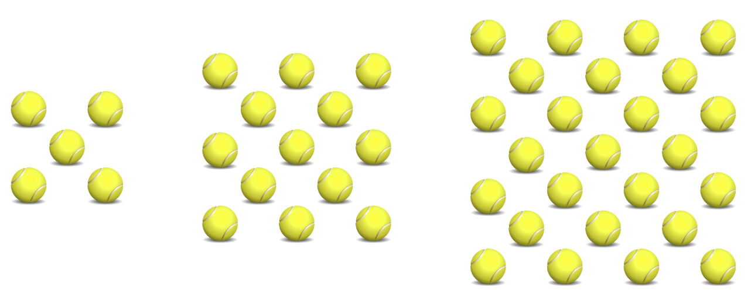

Figure 1
Figure 2
Figure 3

 | Fig 1 | Fig 2 | Fig 3 | Fig 4
Number of tennis balls | 5

Set 4

4a. We call these figures ‘open squares’ (even though the first two are not actually open) .

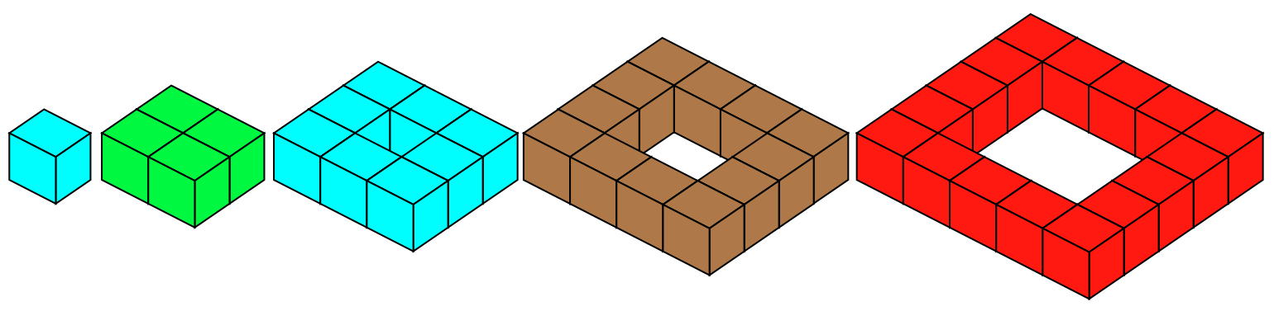

Fig. 1 Fig. 2 Figure 3 Figure 4 Figure 5

Fill in the chart:
 | Fig 1 | Fig 2 | Fig 3 | Fig 4 | Fig 5 | Fig 6
Number of cubes | 1 | 4 | 8

4b.

We now stack the open squares up to make hollow pyramids, each open square resting on the one that I is the next size bigger.
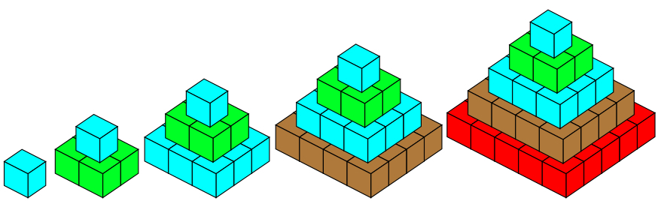

Fig. 1 Fig. 2 Figure 3 Figure 4 Figure 5

 | Fig 1 | Fig 2 | Fig 3 | Fig 4 | Fig 5 | Fig 6
Number of cubes | 1 | 5

.

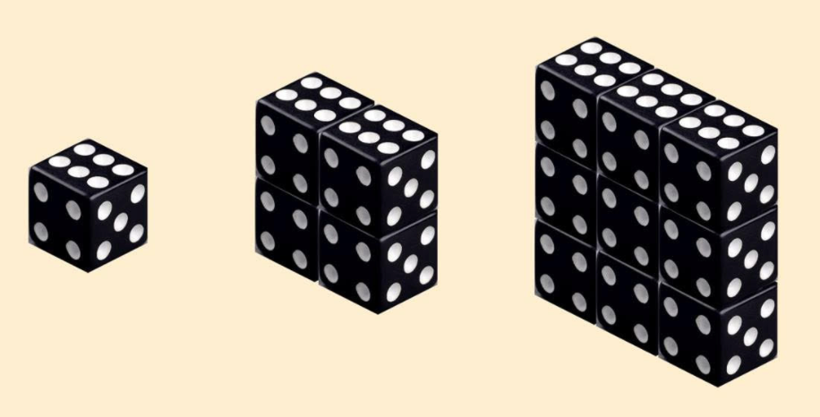
5a.
Set 5

Figure 1
Figure 2
Figure 3

 | Fig 1 | Fig 2 | Fig 3 | Fig 4 | Fig 5 | Fig 6
Number of dice | 1 | 4
Number of dots visible | 15 | 38

5b.
Binary abacus: write the stick values , using zeroes and ones, and convert to base ten.

a) ____________ b) ____________
64 32 16 8 4 2 1

64 32 16 8 4 2 1

c) 104 d) 125

c) 104 d) 125

c) 104 d) 125

c) 104 d) 125

c) 104 d) 125

c) ____________ d) ____________

64 32 16 8 4 2 1

64 32 16 8 4 2 1

c) 104 d) 125

c) 104 d) 125

c) 104 d) 125

c) 104 d) 125

c) 104 d) 125

c) 104 d) 125

Set 6

6a. (Simplify answers and do not answer with fractions inside fractions)

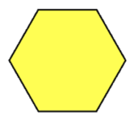
If the hexagon = $\frac{3}{8}$ ,

then the trapezoid = and the triangle =

6b. If the trapezoid = $\frac{3}{8}$ ,

then the rhombus = and the hexagon =

6c. If the rhombus = $\frac{3}{8}$ ,

then the trapezoid = , and the hexagon =

