HW #1 NAME_______________________
TRIMESTER THREE
DUE ________

FEEDBACK FROM TEACHER:
SHOW WORK PLEASE NEATER PLEASE WRITE TIME SPENT PLEASE CORRECT
LEVEL 3 _____ ( √, √+, or √++)

TIME SPENT: ___________________ Student feedback: (optional) ____________________________________________

LEVEL 1 Rulers:
- Label all the fractional markings on this “foot ruler”- simplify when possible.
0
1½
1

- Label all the fractional markings on this “foot ruler”- simplify when possible.
1½
1

- What is this SUM?
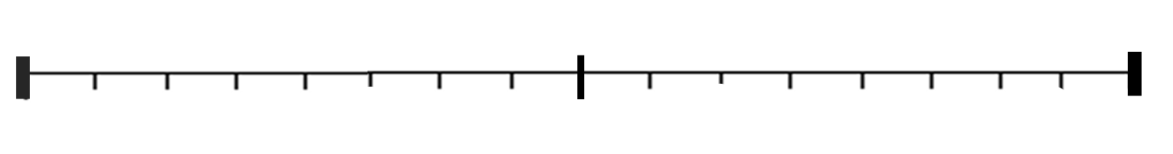
1½
1

- What is this DIFFERENCE?
1
1½

This is being SUBTRACTED

LEVEL 2

#4. a) 2,008 ÷ 40
 | 1,000 | 100 | 10 | 1 | 0.1
Before:
÷ 4
÷ 10

.
.

.

b) 2130 $÷$ 3

 | 1,000 | 100 | 10 | 1 | 0.1
Before:
÷ 3
÷ 100

.
.

#5
- What pattern do you see
in the LEFT “wing” of rhombuses only:

Step 1 1 rhombus

Step 2 4 rh.

Step 3 _____ rh.

Step 4 ______ rh

Step 5 _____ rh.

Step 10 ______ rh.

Challenge:
Step 100 ? _____ rh.

Step “n” ?? ______ rh

Patterns
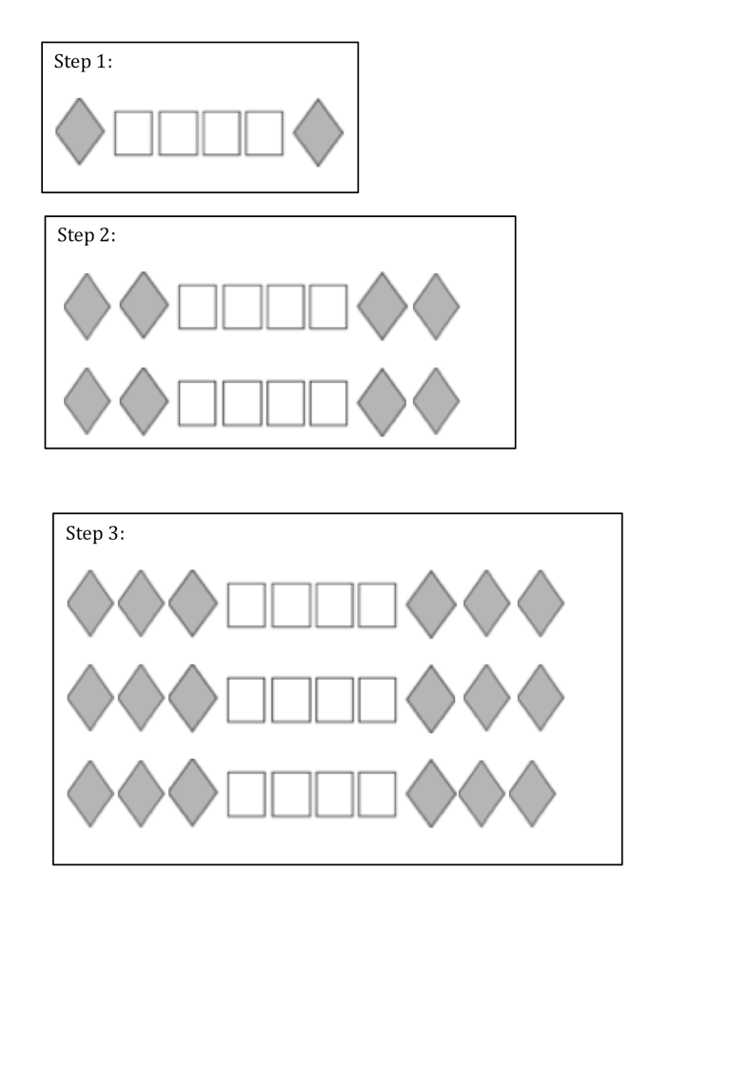
- in the LEFT “wing” of rhombuses only:

Step 1 1 rhombus

Step 2 4 rh.

Step 3 _____ rh.

Step 4 ______ rh

Step 5 _____ rh.

Step 10 ______ rh

Step 100 _____ rh.

Step “n” ______ rh

c) Challenge
What pattern do you see in the TOTAL number of quadrilaterals? (squares and rhombuses)

Step 1 6 quadrilaterals

Step 2 12 qu.

Step 3 _____ qu.

Step 4 ______ qu

Step 10 ________ sq

Step 43 ? ________ sq

Challenge:
Step 10 ? ________ sq

Step 43 ?? ________ sq

b) What pattern do you see in the squares

Step 1 4 squares
Step 2 8 sq.

Step 3 ______ sq.

Step 4 _______ sq.

Challenge:
Step 10 ? ________ sq

Step 43 ?? ________ sq

#6
Multiplication Diamonds:

Multiply

0
50
30
30
6
24
6
6
6
6
5
3
27
17
13

add

LEVEL C, optional challenge - Counting like a computer
Can you draw in the beads for these numbers?

a) 33 b) 17
64 32 16 8 4 2 1

64 32 16 8 4 2 1

64 32 16 8 4 2 1

64 32 16 8 4 2 1

64 32 16 8 4 2 1

64 32 16 8 4 2 1

c) 24 d) 130

128

128

e) 135 f) 193

128

128

