CLASSWORK NAME__________

#1. 4.10 ÷ 20 (4 ones and 10 hundredths)
 | 1,000 | 100 | 10 | 1 | 0.1 | 0.01 | 0.001
Before:
÷ 2
$÷10$

.
.

.

#2. 4.08 $∙$ 30 (4 ones and 8 hundredths)
 | 1,000 | 100 | 10 | 1 | 0.1 | 0.01 | 0.001
Before:
$∙3$
$∙$ 10

.
.

.

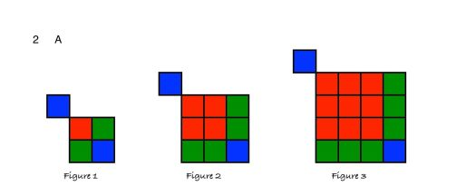
#3. Level 1: What will the next 2 figures in this series look like? Draw whenever needed.

Figure 1 Fig. 2 Fig. 3

 | Figure  1 | Figure  2 | Figure  3 | Figure  4 | Figure 5 | LEVEL 2:  Figure # 19 | LEVEL 3:  Figure “n”
Number of small squares | 5 | 10 | 17 | 1

#4. Solve by drawing $\left(1\frac{2}{3}∙3\right)- \frac{2}{3}$

Draw $1\frac{2}{3}$ 3 times and then cross out $\frac{2}{3}$ .
Count up what’s left.

Mixed
number:

Improper
fraction:

#5. Order of Operations:
Level 2
a) $15÷3-(15÷3)+2 ∙3 ____$

Level 3
#6)
$\left[3^{2}+\left(24÷6 ∙4\right)-2 ∙3\right]$ ÷ 7 = _____

