CW – Multiplication Shortcuts Name______

1. Semi - Mental Math shortcuts - Multiplication
TIP: Look for partial products of 10, 100, and 1000.

EXAMPLES: Look for 10s and 100s
OR
5 • 25 • 2 = 25 • 20 =

10 • 25 = 250 25 • 2 • 10 25 • 4 • 5 =

50 • 10 = 500 100• 5 = 500

a) 2 • 44 • 5 = ______ b) 28 • 5 = ______

14 • 2 • ?

c) 5 • 36 = ______ d) 50 • 200 = ______

e) 2 • 25 • 18 = ______ f) 40 • 22 = ______

___ • 2 • ___

g) 404 • 25 = ______ h) 24 • 25 = ______

___ • 4 • ___

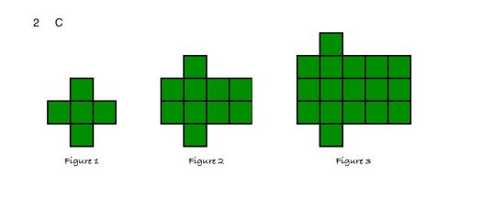
*i) 48 • 125 = ______

___ • 4 • 25 • ___

#2. Find the pattern
 | Figure 1 | Figure 2 | Figure 3 | Figure 4 | Figure 5 | LEVEL 2:  Figure # 10? | LEVEL 3:  Figure #20? | LEVEL 3:  Figure n?
Number of squares | 5 | 10

#3 Powers of 10

a) 203 • 40
 | 1,000 | 100 | 10 | 1 | 0.1
Before:
• 4
• 10

.
.

.

b) 2,008 ÷ 40
 | 1,000 | 100 | 10 | 1 | 0.1
Before:
÷ 4
÷ 10

.
.

.

c) 2130 $÷$ 3
 | 1,000 | 100 | 10 | 1 | 0.1
Before:
÷ 3
÷ 100

.
.

#4 Multiplication Diamonds:

Multiply

0
70
70
63
7
28
7
6
6
5
7
71
17
16

add

Logic Problem – 2 puzzle points

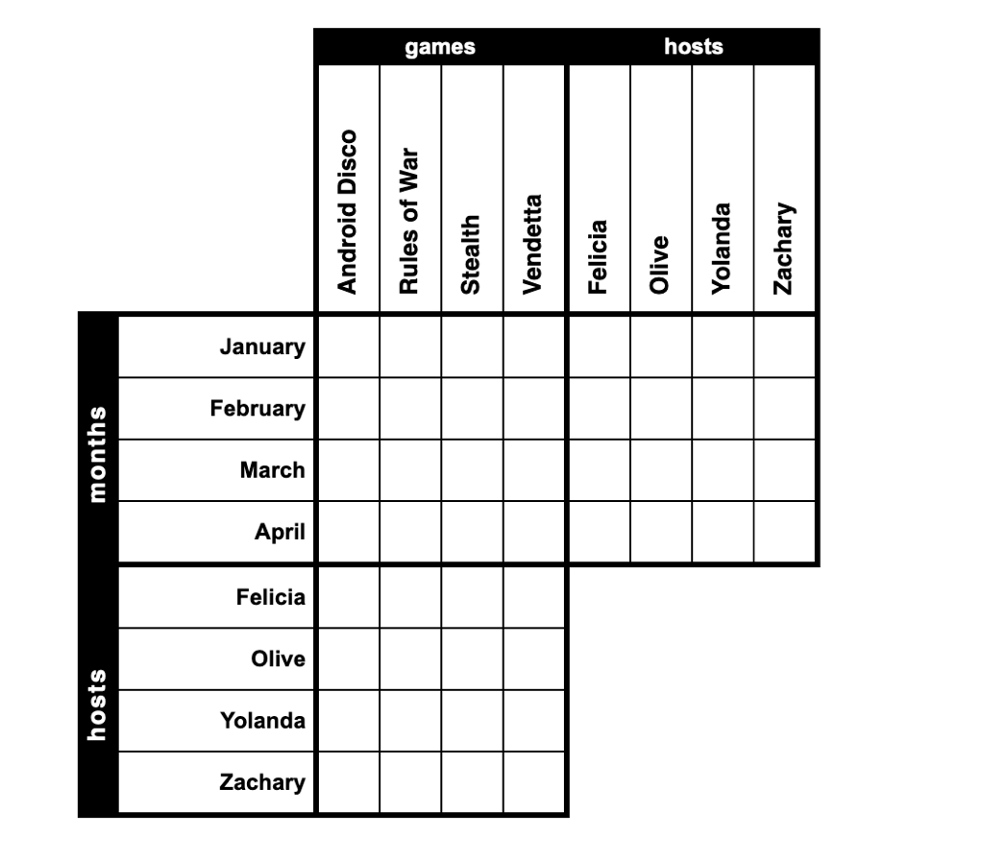
The Byronville Gaming Club holds one "game night" each month, at which a number of members gather to play a different board game.

Clues
1. Android Disco, the board game hosted at Olive's house and the game hosted at Felicia's house were all different games.
2. Rules of War was played in February.
3. Stealth was hosted by Felicia.
4. The board game played in January was either Android Disco or the board game hosted at Yolanda's house.
5. The board game hosted at Yolanda's house was played 2 months before Android Disco.

